Hart Publishing is delighted to give you information about their latest title

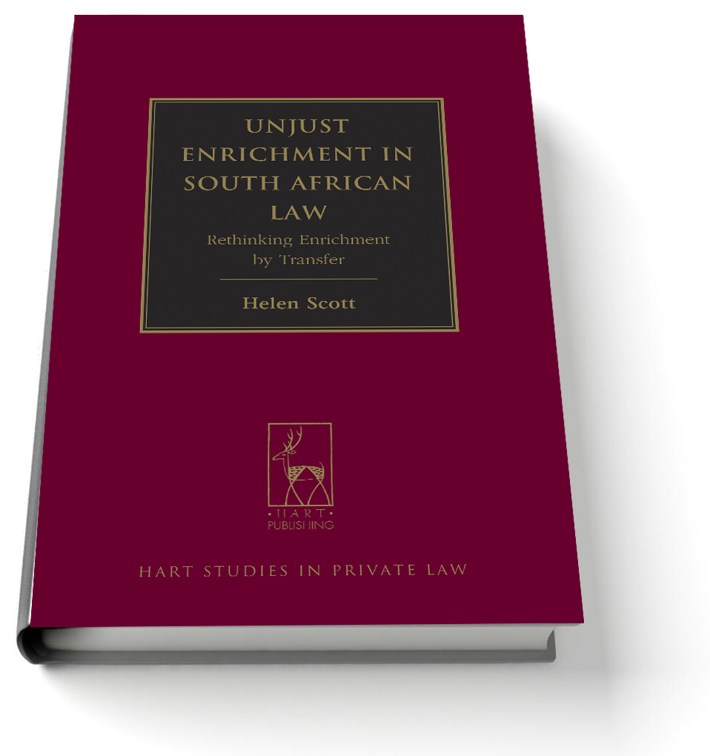
Unjust Enrichment in South African Law
Rethinking Enrichment by Transfer
By Helen Scott

Conventional thinking teaches that the absence of liability - in particular contractual invalidity - is itself the reason for the restitution of transfers in the South African law of unjustified enrichment. However, this book argues that while the absence of a relationship of indebtedness is a necessary condition for restitution in such cases, it is not a sufficient condition. The book takes as its focus those instances in which the invalidity thesis is strongest, namely, those traditionally classified as instances of the condictio indebiti, the claim to recover undue transfers. It seeks to demonstrate that in all such instances it is necessary for the plaintiff to show not only the absence of his liability to transfer but also a specific reason for restitution, such as mistake, compulsion or incapacity. Furthermore, this book explores the reasons for the rise of unjust factors in South African law, attributing this development in part to the influence of the Roman-Dutch restitutio in integrum, an extraordinary, equitable remedy that has historically operated independently of the established enrichment remedies of the civilian tradition, and which even now remains imperfectly integrated into the substantive law of enrichment. Finally, the book seeks to defend in principled terms the mixed approach to enrichment by transfer (an approach based both on unjust factors and on the absence of a legal ground) which appears to characterise modern South African law. It advocates the rationalisation of the causes of action comprised within the condictio indebiti, many of which are subject to additional historically-determined requirements, in light of this mixed analysis.

Helen Scott is an Associate Professor in the Department of Private Law at the University of Cape Town.

Please click here to view the table of contents for this book

July 2013 250pp Hbk 9781849462235 RSP: £55
Discount Price: £44

As a member of the Obligations Discussion Group Hart Publishing is delighted to offer you 20% discount.
ORDER ON-LINE
Please click here to order online. When ordering online please type the reference 'ODG' in the voucher code field and click ‘apply’ to receive the discount.

Alternatively, please contact Hart Publishing and quote reference ‘ODG’ to receive the 20% discount.
Hart Publishing Ltd, 16C Worcester Place Oxford OX1 2JW, UK
Tel: +44 (0)1865 517530 Fax: +44 (0)1865 510710
E-mail: mail@hartpub.co.uk; Website: http://www.hartpub.co.uk

